Department of Information Science and Engineering

A Report on KCET – Knowledge & Career Enhancement Talk
ALUMNI TALK | Month - NOVEMBER| YEAR - 2025

Knowledge & Career Enhancement Talk Series
A REPORT ON ALUMNI TALK

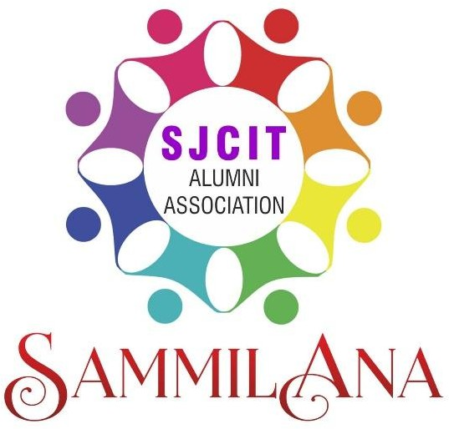

DATE : 7.11.2025 | TIME : 10.00 A M

PROGRAM POSTER

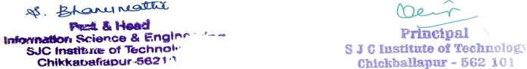

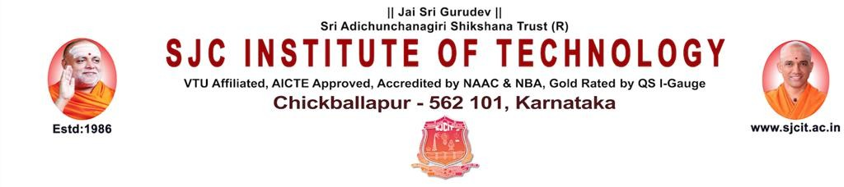
PROFILE OF RESOURCE PERSON

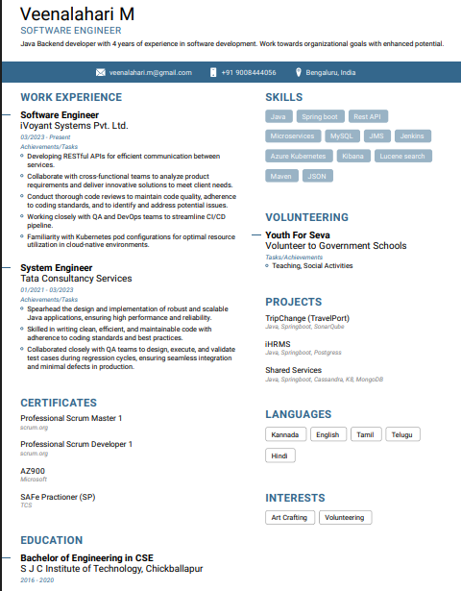

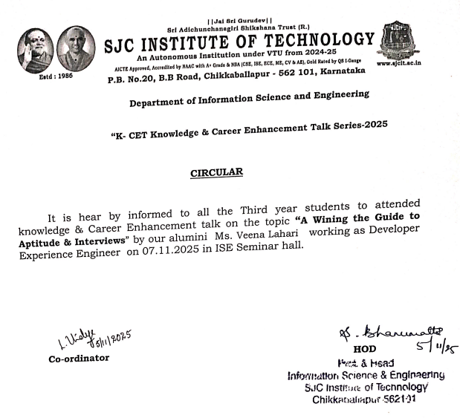

|| Jai Sri Gurudev ||
S J C Institute of Technology Department of information science and engineering

Date: 7-11-2025
Time 10.00am

ISE ALUMNI TALK SERIES - 2025
Program Conduction Schedule

Activity | Name of the in charge
Anchoring | Miss. Chandana M
Display of alumni talk series poster | Mrs. Vindya L
Interaction with alumni | Mrs. Vindya L
Welcome speech | Mr. Anand Tilagul
Profile Reading | Miss. Chandana M
Address By HOD | Dr. Bhanumathi S
Address by Co-ordinator | Mrs. Vindya L
Interaction by alumni | Miss. Veena Lahari
Vote of thanks | Mr. Anand Tilagul

- To equip students with the essential knowledge, strategies, and confidence required to successfully clear aptitude tests and performs effectively in campus placement interviews.
- The session aimed to bridge the gap between academic preparation and industry expectations by sharing real-time insights, practical tips, and experiences from a successful alumnus.
- To provide mentoring, facilitating internships, and career opportunities to students

PROGRAM OUTCOME / SESSION TAKEAWAY

- Understand the recruitment process followed in campus placements, including stages such as aptitude tests, group discussions, technical rounds, and HR interviews.
- Identify key aptitude topics commonly tested by recruiters and learn effective problem-solving techniques to improve accuracy and speed.
- Gain clarity on interview preparation, including resume building, self-introduction, body language, communication skills, and handling common interview questions.
- Learn practical tips and strategies from the alumnus’s personal experience to overcome challenges during placement drives.
- Enhance confidence and readiness for participating in upcoming placement activities through interactive discussions and Q&A.
- Recognize the importance of continuous improvement, skill development, and industry awareness for long-term career growth.

GLIMPSES OF PROGRAM

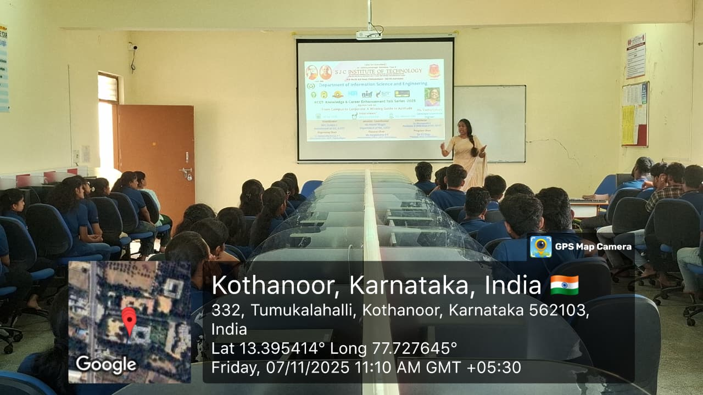

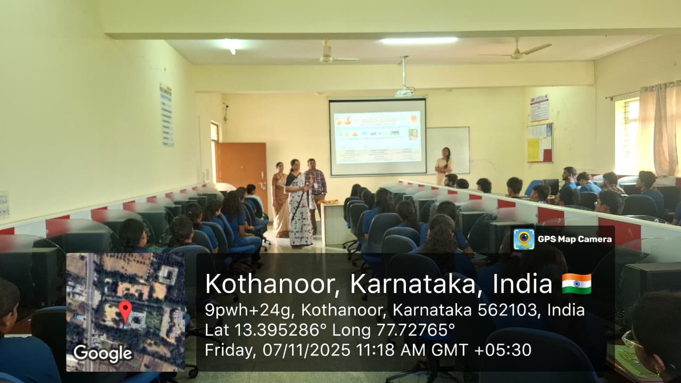

FEEDBACK – COPY OF GOOGLE FORM
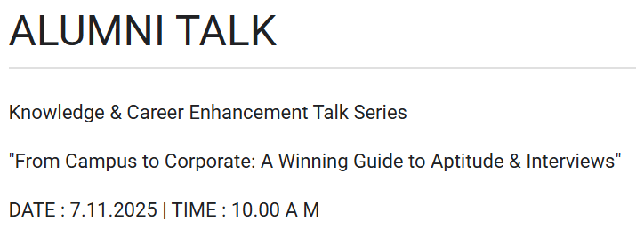
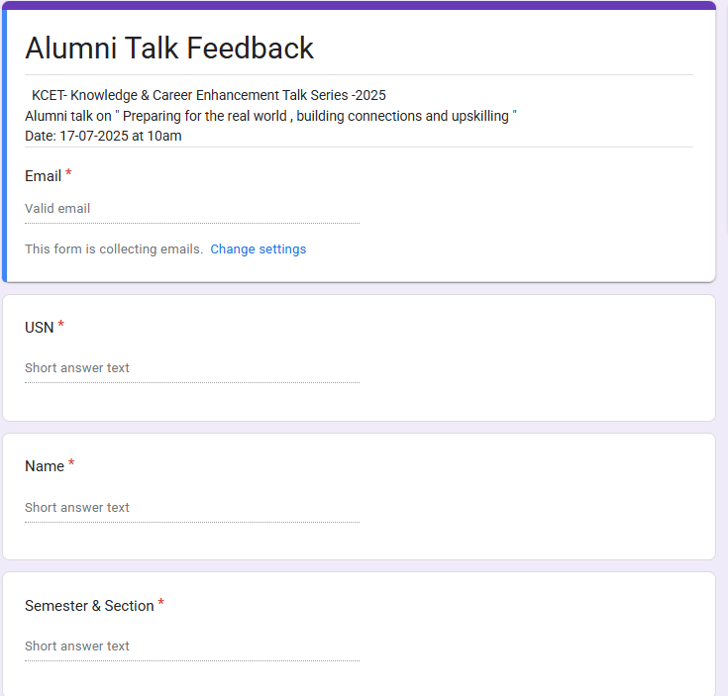
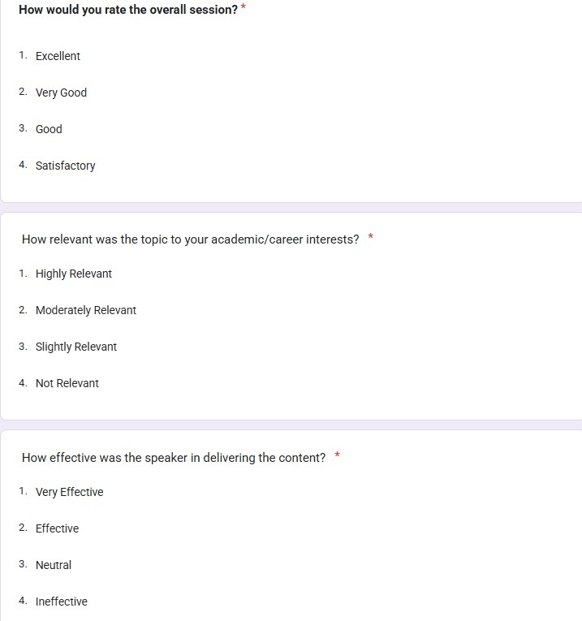
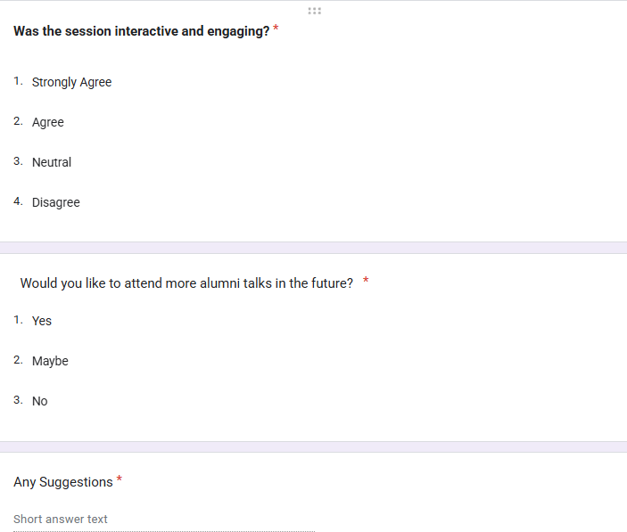

FEEDBACK –Sample Copy of RESPONSES RECEIVED
